**imread** ('path of file')

[m n] = **size**(matrix which has the image)

imfinfo name of file

who

whos can be given with the variable too

what

which variable name // can make use of * ?

clear all

load

save

impixelinfo,imshow(f); run in editor

imfinfo filename

imwrite (file, ‘quality’ , value)

logical(A) converts the array to binary image

islogical function to check if the array is made only of 0 and 1

mat2gray () to convert the array into the range of [0 1]

input can be just the array or Array , [min max]

**Im2double** similar to mat2gray but no range can be applied

**im2bw** (a,L)convert image a to binary where L is the threshold value the intensity levels below this L are given value 0 and above it are given value 1. By default

L=graythresh(I) calculates the threshhoild value

Disp(A) prints the output A into the screen

Array

For most of the operations In the arrays we take a col as a vector and perform operation on it and return a row as output. So first change the 2d array to 1 col

x.’= transpose

x(1:a:b) print the rows after gap of a till bth row

if the array x is 2D then we can put conditions on both row and column

like x(1:3, 2:4) will print rows 1,2,3 and only their col 2,3,4

E=A([1 3], [2 3])

A(D) where D is logical

Sum(A) will generate a row vector which has the sum of all the column values

Numel returns the umber of elements in the array

To invert an iamge

F(end:-1:1, :)

To take mirror image

F(: , end:-1:1 )

Ndims(a) gives the dimension of the array

Zero

Ones

True

False

Magic

Randn(M N)

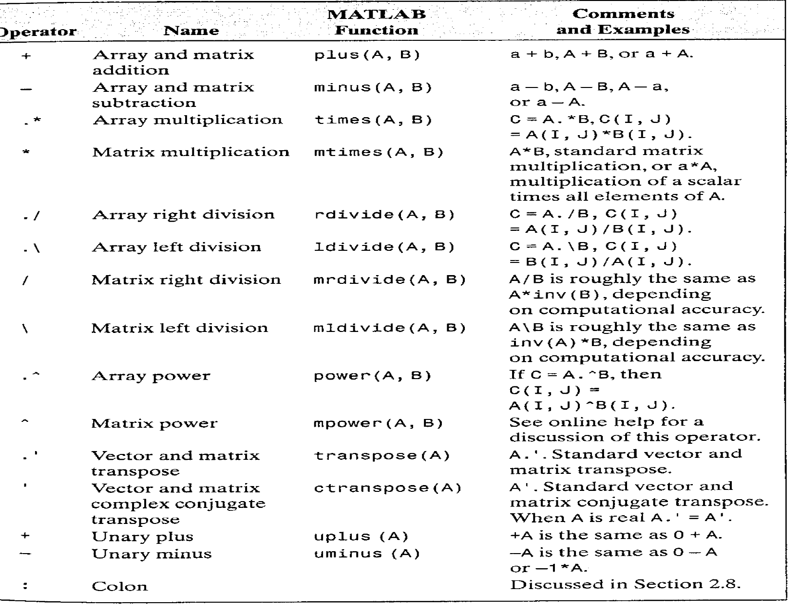

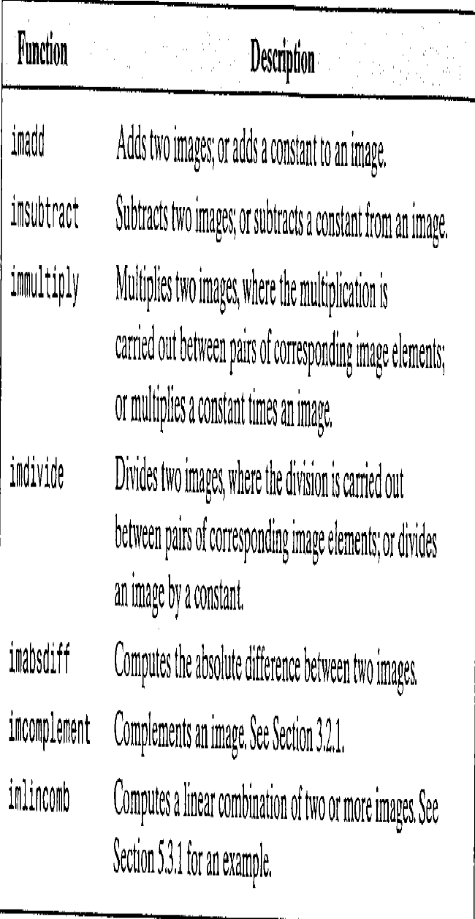

MAX(A)

IMADJUST( f, \\

Log

C*log(1+double(f))

Contrast strechting

1./(m./(double(f)+eps).^E+1)

Histogram matching

histeg(image)

histeq(image, hitogram)